**DOCKERS INSTALLATION**

Click on the following link to download the executable file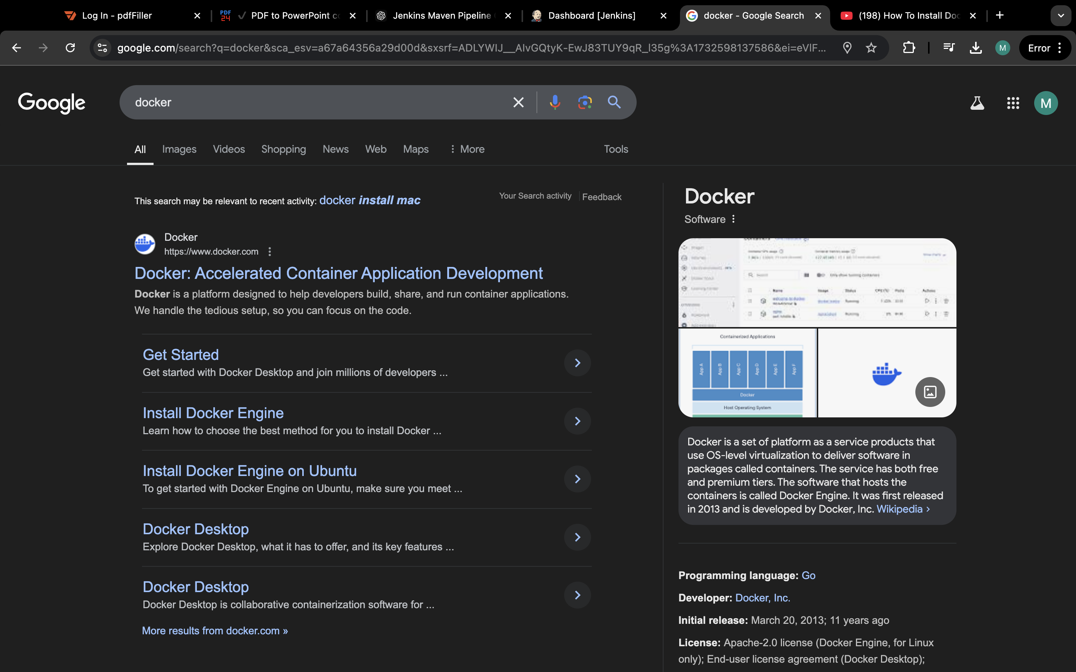

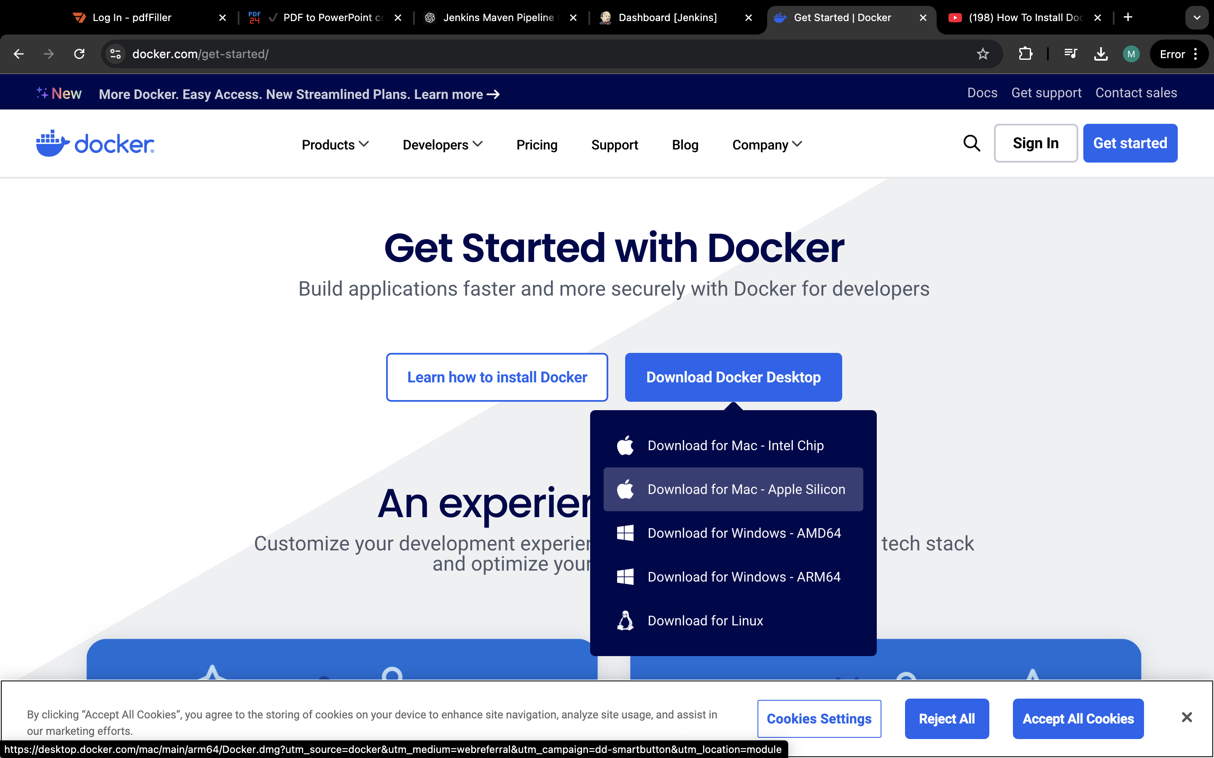

The local Docker Hub is created

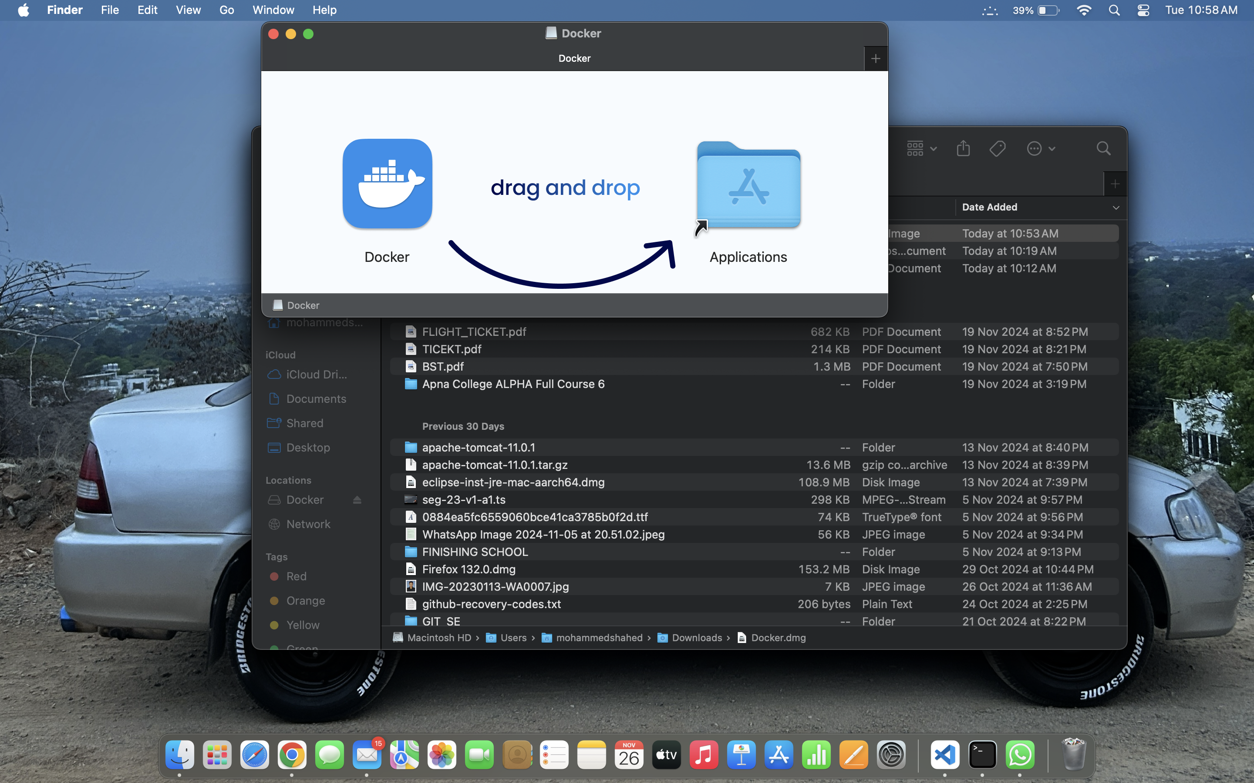

Open PowerShell and enter the command as shown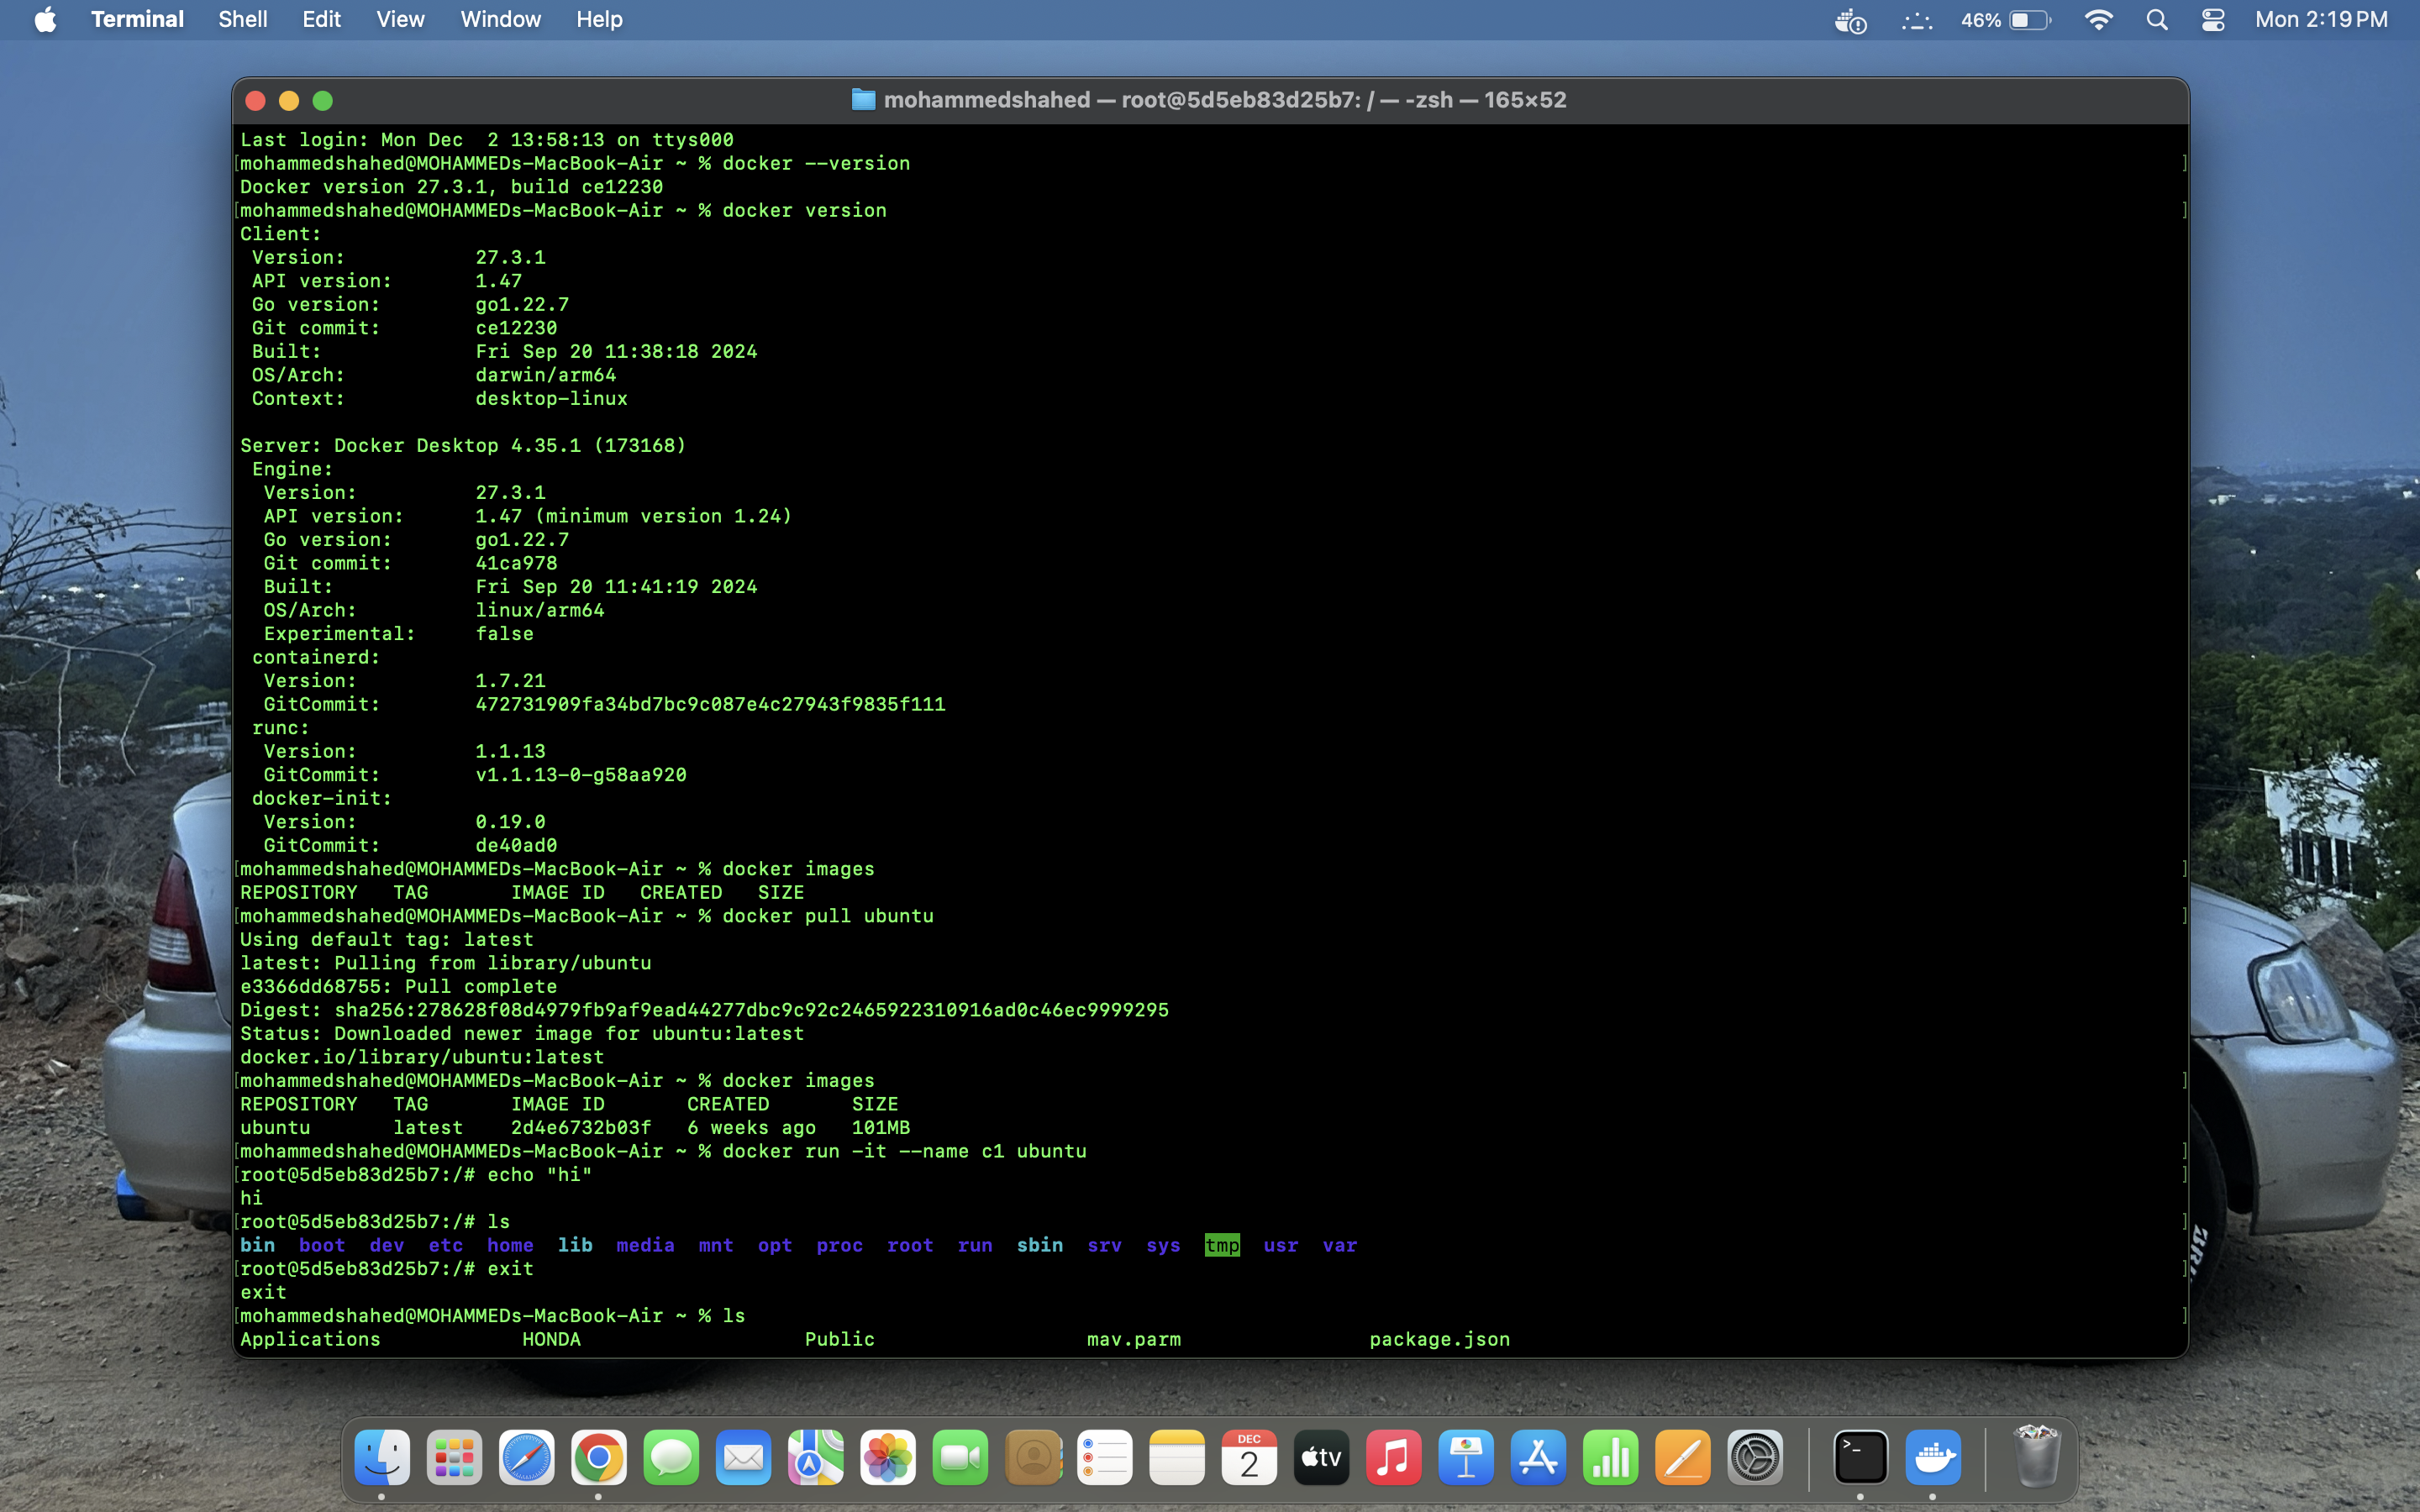

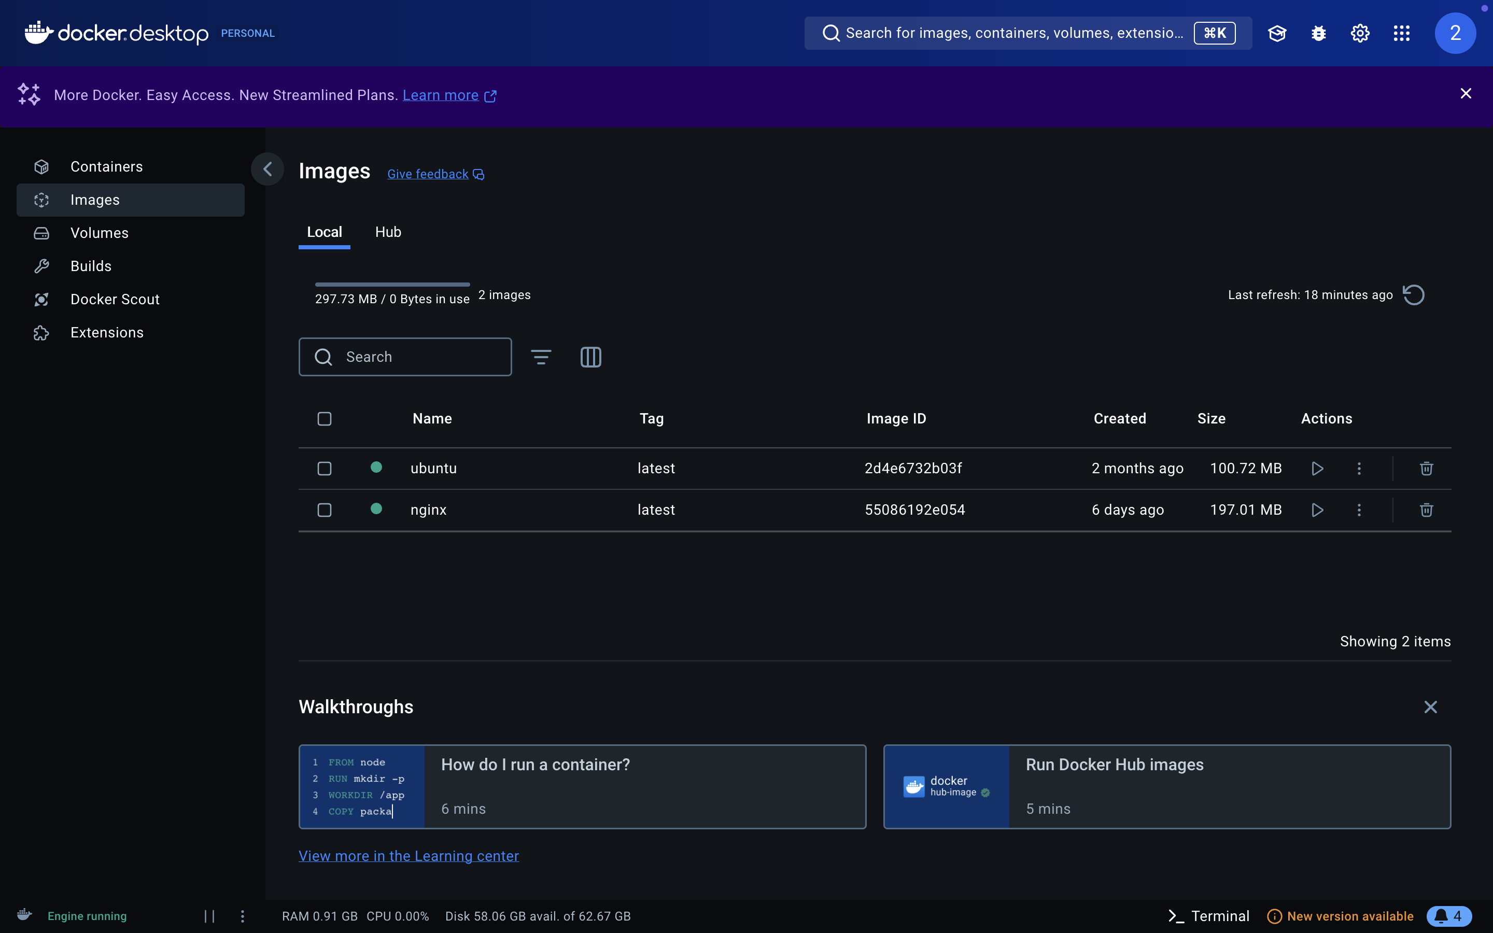

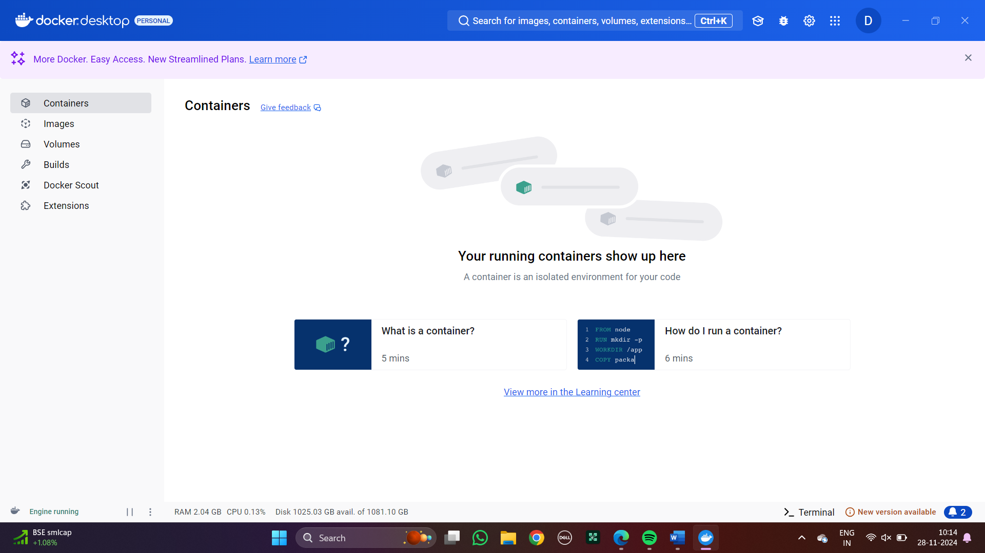

**JENKINS-SCRIPT**

Step 1: Create a new item as jenkins script and opt for pipeline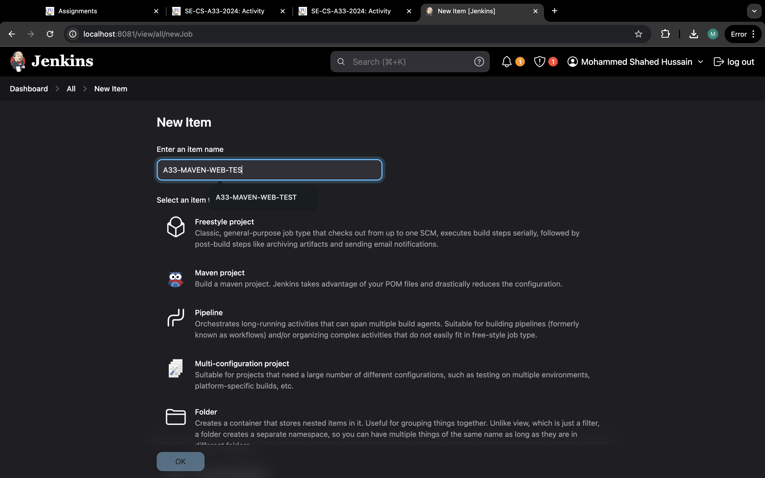

Step 2: Write the Script code with git hub link

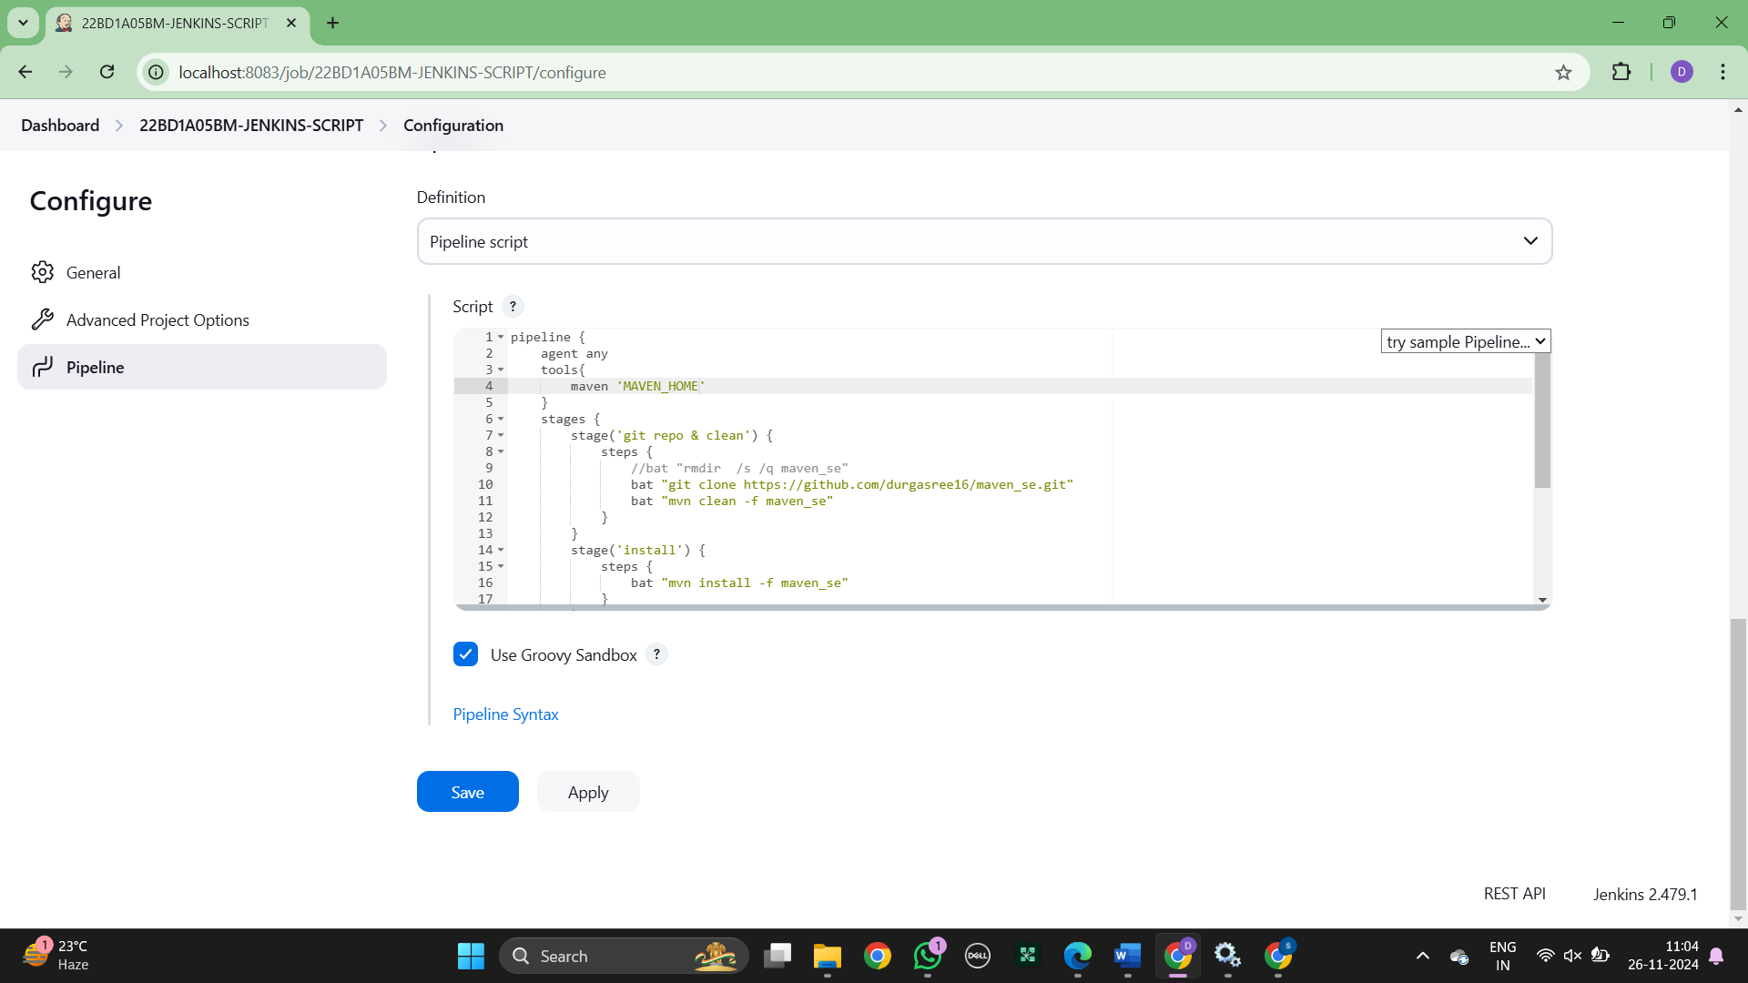

Step 3: Run the script as stages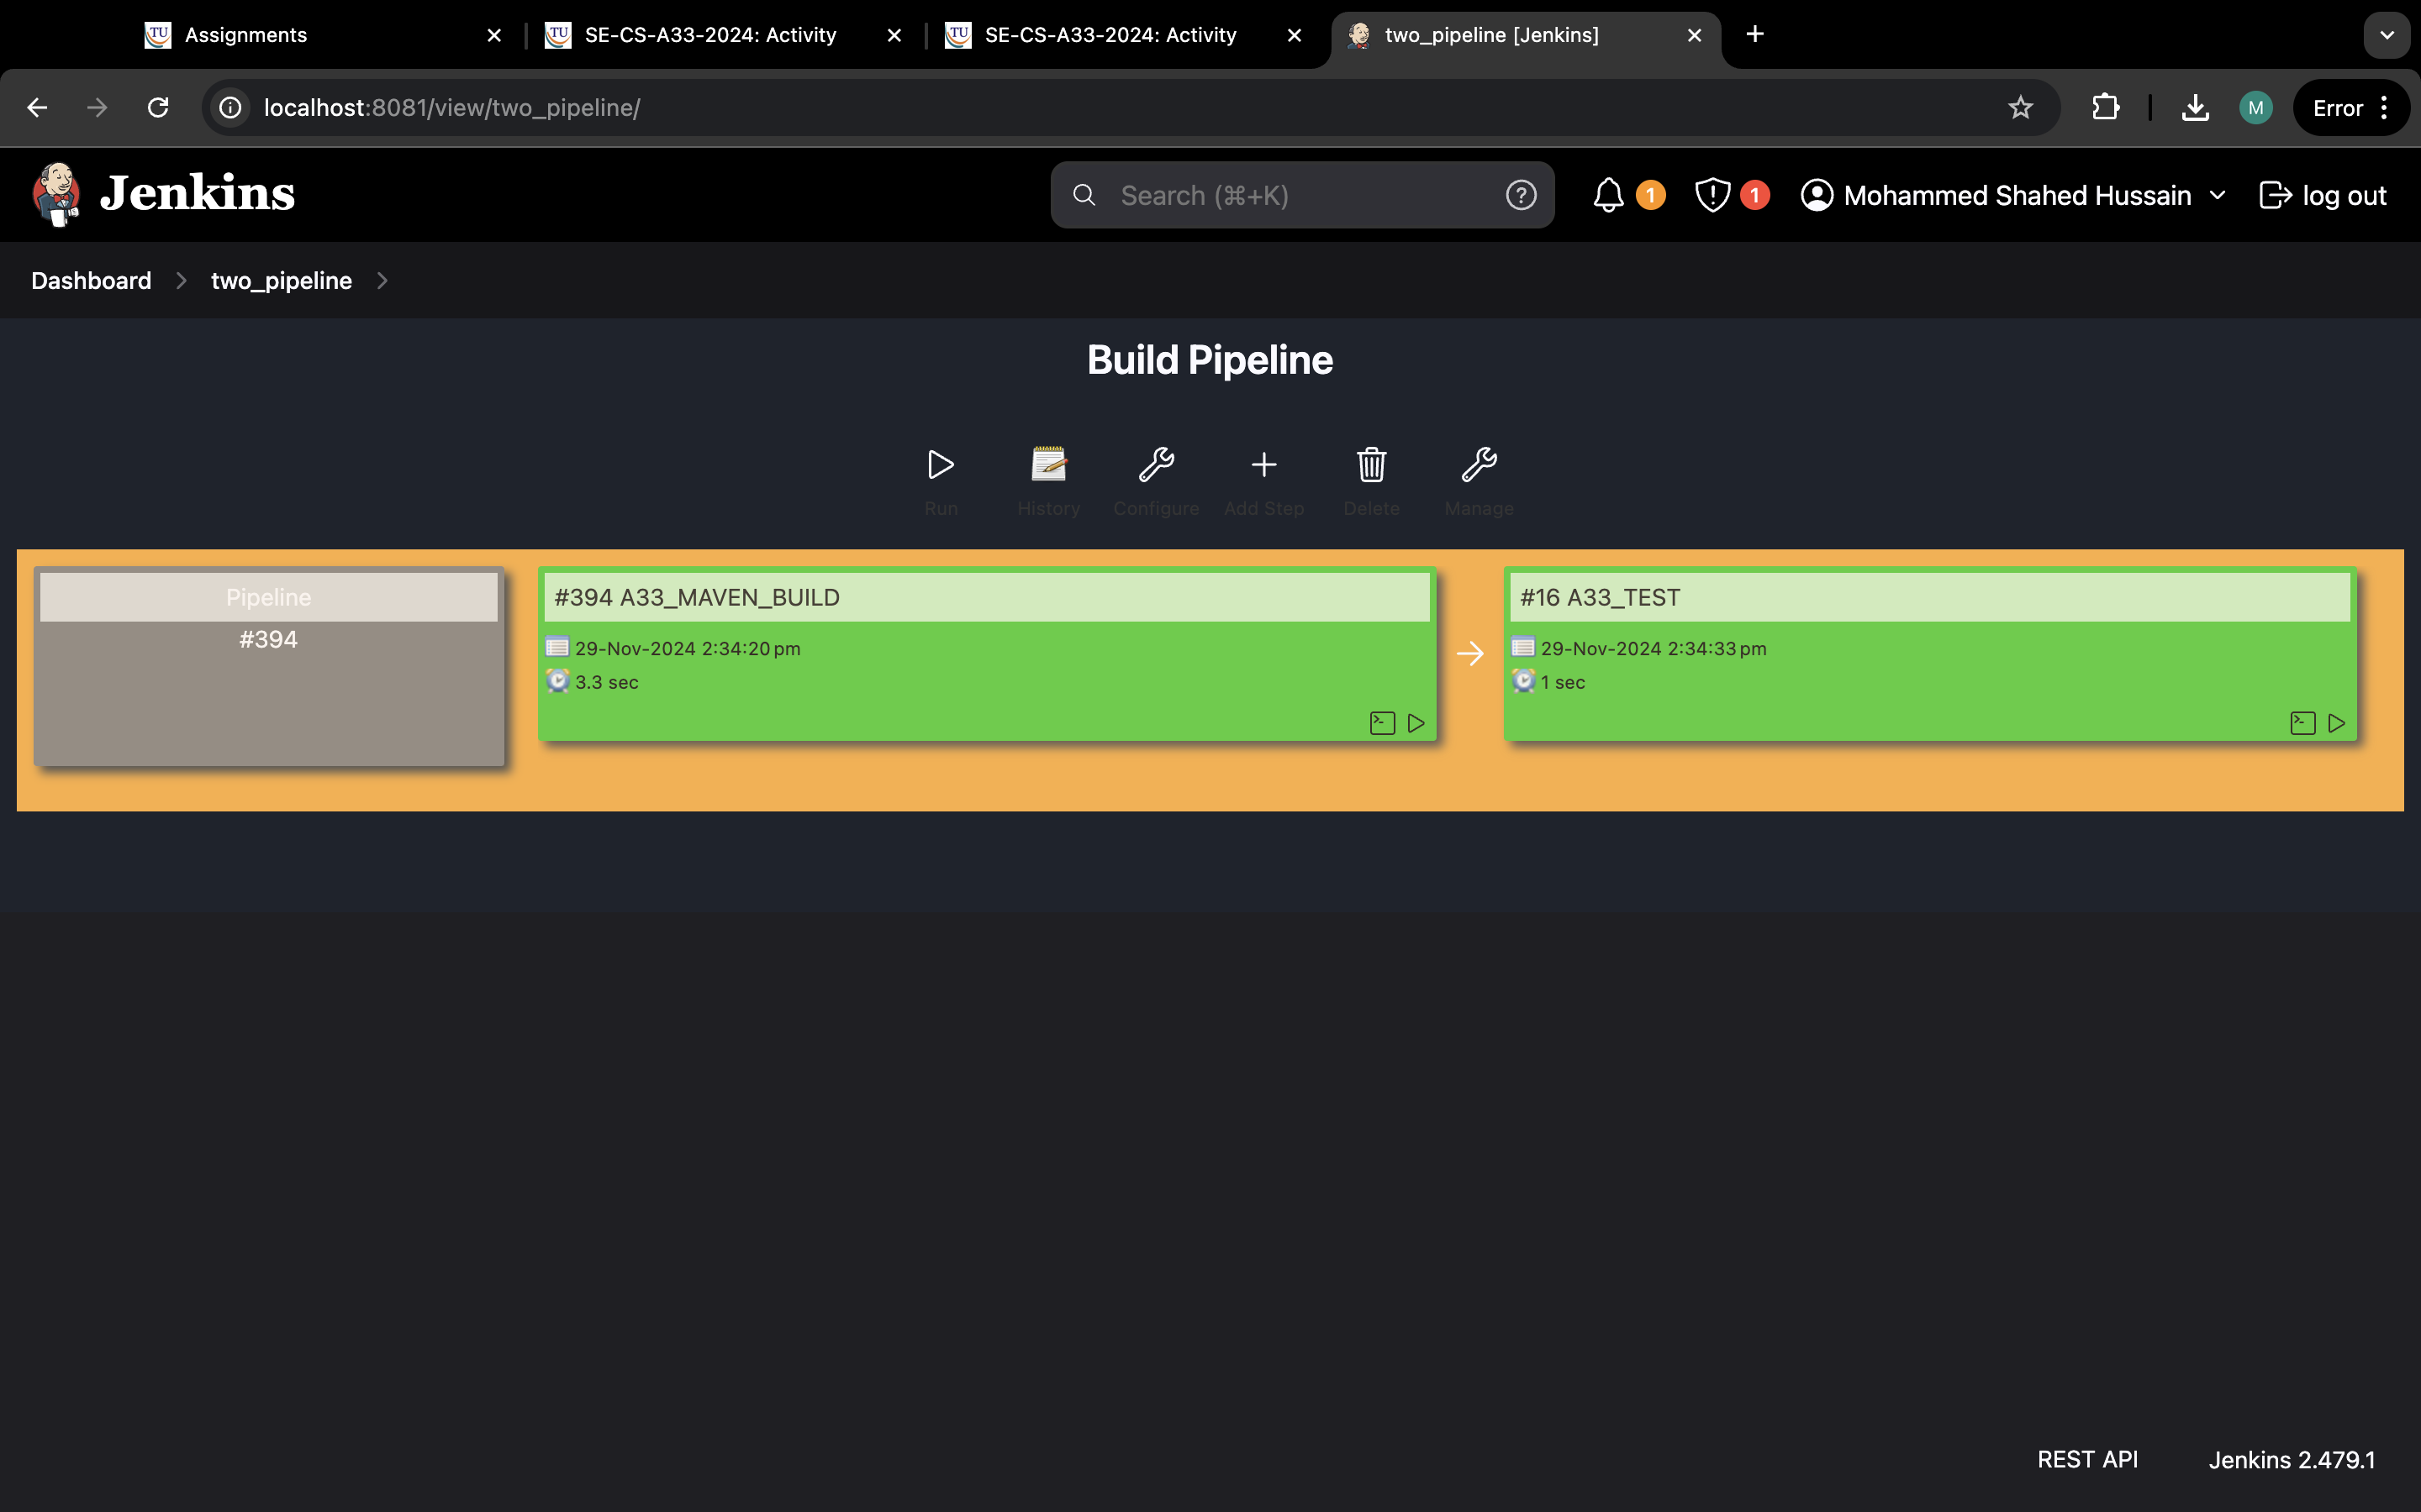

Step 4 : Install the Stage View Pipeline from plugins and the below stages are displayed